Emerging Trends

Domain-driven design

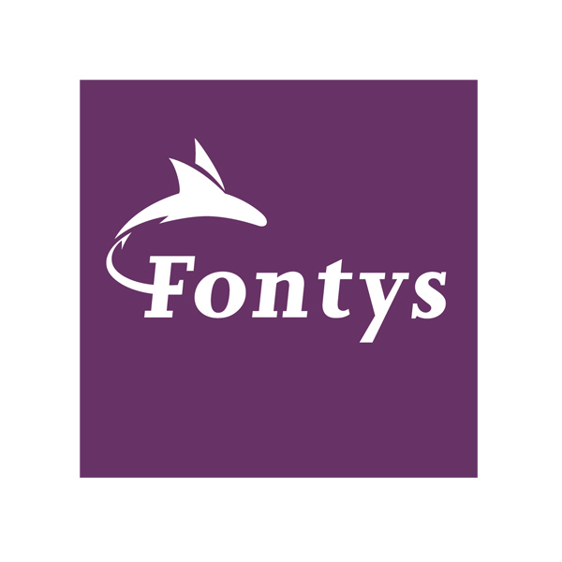

|  |  |
| --- | --- |
| **Date** | 08-03-2021 |
| **Version** | 0.1 |
| **Student Name** | Lars van den Brandt |
| **Student Number** | 434565 |
| **Teacher Fontys** | Tom Meulensteen & Marcel Boelaars |

#### Version

|  |  |  |  |  |
| --- | --- | --- | --- | --- |
| **Version** | **Date** | **Author** | **Changes** | **Status document** |
| 0.1 | 08-03-2021 | Lars van den Brandt | First draft | Waiting for feedback |

#### Distribution

|  |  |  |
| --- | --- | --- |
| **Version** | **Date** | **Name** |
| 0.1 | 08-03-2021 | Tom Meulensteen & Marcel Boelaars |

# Introduction

Software development is fairly new to the world, but it is a subject that keeps evolving and expanding. There are several methods used in the creation of software. Domain-Driven Design (DDD) is an approach used in software development. It puts the focus on the desire and the problem, rather than the solution.   
This document contains the research plan for my research about Domain-Driven Design. The research will be carried out by answering one main question, supported by several sub-questions.

# Problem/opportunity

Domain-Driven Design is a subject that I myself do not yet have much knowledge about. I see this research as an opportunity to gain more knowledge about this subject. By defining and researching the main and sub-questions I will be able to make this opportunity a reality.

# Research questions

### Main question

Why do we need Domain-Driven Design, when developing software.

### Sub-questions

What Software Design approaches are there?

What is Domain-Driven Design?

Why would we use Domain-Driven Design?

What is the downside of Domain-Driven Design?

# Research methods

The research will be done by using the DOT Framework, this framework will help improve the quality of the research. The DOT Framework is a toolset, that uses different methods that are commonly used in ICT. The toolset puts the focus on the research of a product or method.   
Using this framework, no new knowledge will be created. This is done, for example, in a scientific study.

Every sub-question will be answered using the [DOT Framework](https://ictresearchmethods.nl/The_DOT_Framework).

The methods that I intend to use are:

* [*Available product analysis*](https://ictresearchmethods.nl/Available_product_analysis)

By looking into existing research, I intend to answer sub-questions.

* [*Gap analysis*](https://ictresearchmethods.nl/Gap_analyisis)

By comparing Domain-Driven Design to other design approaches, I will be able to learn more about the differences and the desired situations.

* [*SWOT analysis*](https://ictresearchmethods.nl/SWOT_analysis)

By identifying several strengths, weaknesses, opportunities and threats about Domain-Driven Design, I will be able to learn more about the subject itself.

* [*Decomposition*](https://ictresearchmethods.nl/Decomposition)

By dividing the subject in smaller parts, it will be easier to get a research of better quality.

* [*Literature study*](https://ictresearchmethods.nl/Literature_study)

By researching relevant keywords, I hope to find interesting material that I can use in my own research.

* [*Best good and bad practices*](https://ictresearchmethods.nl/Best_good_and_bad_practices)

By talking with other students that also chose the subject: Domain-Driven Design, I hope to exchange knowledge that can the help both of us.

# Timeline & deliverables

The emerging trends research has to be delivered on June 12 (week 16).   
In total I guess I will be working on this research between 16 and 20 hours. I am not sure if this would be too much time, or not enough. But because the deadline is so far away, I can always make more time for this research.

In the end I intend to deliver the research document. This document will contain the answer to the main question, supported by the answers of the sub-questions.

Bron 1: <https://www.bergler.nl/domain-driven-design-in-gewoon-nederlands-artikel-2-het-model/>

Bron 2: <https://en.wikipedia.org/wiki/Domain-driven_design>

Bron 3: <https://www.isaac.nl/nl/nieuws/waarom-je-domain-driven-design-nodig-hebt-ook-als-je-nu-denkt-van-niet>

Bron 3: <https://ictresearchmethods.nl/The_DOT_Framework>